Profile of

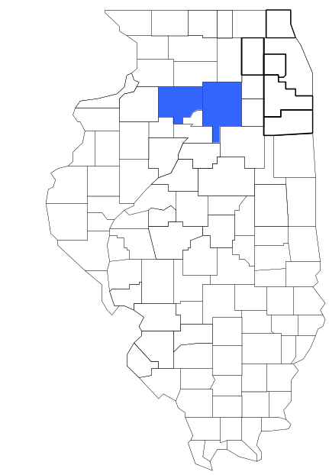Task Force 17

Prepared by

The Research and Analysis Unit of the
Illinois Criminal Justice Information Authority

George H. Ryan, Governor
Peter B. Bensinger, Chairman
Candice M. Kane, Executive Director

March 2001



ILLINOIS
CRIMINAL JUSTICE
INFORMATION AUTHORITY

This project was supported by Grant # 99-DB-BX-0017, awarded to the Illinois Criminal Justice Information Authority by the Bureau of Justice Assistance, Office of Justice Programs, U.S. Department of Justice. The Assistant Attorney General, Office of Justice Programs, coordinates the activities of the following programs, offices and bureaus: Bureau of Justice Assistance, Bureau of Justice Statistics, National Institute of Justice, Office of Juvenile Justice and Delinquency Prevention, and the Office for Victims of Crime. Points of view or opinions contained within this document are those of the authors and do not necessarily represent the official position or policies of the U.S. Department of Justice.

Illinois Criminal Justice Information Authority
120 S. Riverside Plaza, Suite 1016
Chicago, Illinois 60606-3997
Telephone (312) 793-8550
Telefax (312) 793-8422
TDD: (312) 793-4170
World Wide Website http://www.icjia.state.il.us
ACKNOWLEDGMENTS

A number of organizations and individuals put a great deal of effort into the development of this document. The Authority’s Research and Analysis Unit is very grateful for the assistance provided by the following organizations:

Administrative Office of the Illinois Courts
Illinois Department of Human Services’ Office of Alcoholism and Substance Abuse
Illinois Department of Children and Family Services
Illinois Department of Corrections
Illinois State Police
Task Force 17
U.S. Bureau of the Census

In addition, the following individuals were instrumental in gathering, interpreting and presenting these data:

Sharyn Adams

Megan Alderden

Robert Bauer

Alissa Clark

John Condne

Karen Griffiths

Tracy Hahn

Jennifer Hiselman

David Katz

Joseph Kozenczak

Gary Kupsak

Erica Morrow

David Olson

Adrianna Perez

Gerard Ramker

Robert Taylor

CONTENTS

Section Page Number

EXECUTIVE SUMMARY

I. Introduction 1
II. Trends in Violent Index Offenses and Arrests 3
III. Trends in Drug Arrests 6
IV. Trends in Drug Seizures 14
V. Trends in Prosecutions for Drug Offenses 16
VI. Trends in Percent of Convicted Drug Offenders Sentenced to Prison 18
VII. Trends in Drug Treatment Admissions in Task Force 17 Region by Drug Type 23
VIII. Trends in Drug Exposed Births 26
IX. Summary of Drug Situation 27
X. Appendices 29
Map 1 1999 Percent of Illinois' County-level Population Covered by an
Authority-funded Multi-jurisdictional Enforcement Group or Task Force 30
Map 2 1999 Illinois Cannabis Seizure Rates, by County 31
Map 3 1999 Illinois Controlled Substances Seizure Rates, by County 32
Map 4 1999 Illinois Methamphetamine Seizure Rates, by County 33
XI. Bibliography 34

LIST OF FIGURES

Figure Page Number

Figure 1. Violent Index Offense Rates for Participating and Non-participating Agencies in Region Covered by Task Force 17 3
Figure 2. 1999 Violent Index Offenses* Reported by Participating and Non-participating Agencies in Region Covered by Task Force 17 4
Figure 3. Violent Index Arrest Rates for Participating and Non-participating Agencies in Region Covered by Task Force 17 5
Figure 4. 1999 Violent Index Arrests* Reported by Participating and Non-participating Agencies in Region Covered by Task Force 17 5
Figure 5. Total Drug Arrest Rates for Task Force 17 and Participating and Non-participating Agencies in Region Covered by Task Force 17 7
Figure 6. 1999 Drug Arrests* Reported by Participating and Non-participating Agencies in Region Covered by Task Force 17 7
Figure 7. Total 1999 Drug Arrests* Reported by Participating and Non-participating Agencies in Region Covered by Task Force 17, by Drug Type 8
Figure 8. Drug Arrests by Task Force 17 9
Figure 9. Percent of Total Drug Arrests Accounted for by Task Force 17 9
Figure 10. Cannabis Arrests Rates in the Region Covered by Task Force 17 as Reported by Participating Agencies, Non-participating Agencies and Task Force 17 10
Figure 11. Percent of Cannabis Arrests Accounted for by Task Force 17
11
Figure 12. Controlled Substances Arrest Rates in the Region Covered by Task Force 17 as Reported by Participating Agencies, Non-participating Agencies and Task Force 17 12
Figure 13. Percent of Controlled Substances Arrests Accounted for by Task Force 17 12
Figure 14. Task Force 17 Drug Arrests for Possession versus Delivery, by Drug Type 13
Figure 15. Cannabis Seized and Submitted to ISP by Bureau and LaSalle Counties and Seized by Task Force 17 14
Figure 16. Powder and Crack Cocaine Seized and Submitted to ISP by Bureau and LaSalle Counties and Seized by Task Forece17 15
Figure 17. Number of Felony Filings in Bureau and LaSalle Counties 16
Figure 18. Total Task Force 17 Drug Arrests and Percentage of Arrests Resulting in Prosecution 17
Figure 19. Sentences Imposed on Felons Convicted in Bureau and LaSalle Counties
18
Figure 20. Sentences Imposed on Convicted Task Force 17 Drug Offenders 19
Figure 21. Number of Drug Offenders Committed to IDOC by Task Force 17 and Region Covered by Task Force 17 20
Figure 22. Drug Offenders as a Percent of Total IDOC Commitments from Bureau and LaSalle Counties 21
Figure 23. Drug Offenders Committed to IDOC from Bureau and LaSalle Counties, by Offense Class 22
Figure 24. Substance Abuse Treatment Admissions from Bureau and LaSalle Counties 23
Figure 25. Comparison of Drug Arrests by Task Force 17 and Participating and Non-participating Agencies vs. Drug Abuse Treatment Admissions in Bureau and LaSalle Counties, SFY 99 25
Figure 26. Cases of Drug-Exposed Infants in Bureau and LaSalle Counties 26
Figure 27. Availability of Drugs in Illinois, 1998 27
Figure 28. Price Per Gram in Illinois, 1998 28

EXECUTIVE SUMMARY

Since 1989, the Authority’s Research and Analysis Unit has received funds under the federal Anti-Drug Abuse Act of 1988 to document the extent and nature of drug and violent crime in Illinois and the criminal justice system’s response to these offenses. As a result of these efforts, the Authority has amassed a large amount of data measuring the extent and nature of drug and violent crime in Illinois and the impact these crimes have had on the criminal justice system. In addition, as part of its monitoring and evaluation efforts, the Authority also requires funded programs to submit monthly data reports describing their activities and accomplishments. This profile is intended to provide a general overview of the drug and violent crime problem in the jurisdictions covered by Illinois’ MEGs and task forces, and the response to these problems by the units.

Although the data presented in this report are by no means inclusive of all indicators, they do provide a general overview of drug and violent crime and the response and impact of the criminal justice system. The following represent general conclusions that can be made based on the data analyzed for this report.

- In 1999, six local Illinois police agencies participated in Task Force 17 (a participating agency is defined as one that contributes either personnel or financial resources to Task Force 17). Officers assigned to Task Force 17 (totaling eight in 1999, six from participating agencies) accounted for less than 5 percent of the total number of sworn police officers working for agencies participating in Task Force 17.

- The violent Index offense rate was collectively higher across jurisdictions that did not participate in Task Force 17 than among the combined jurisdictions that did participate in Task Force 17 (page 3).

- The drug arrest rate was collectively higher in those jurisdictions that participated in Task Force 17 than in those jurisdictions that did not participating in Task Force 17. The drug arrest rate achieved by Task Force 17 during the same period was lower than the rates achieved by both participating and non-participating agencies, although, the unit with just eight officers, made one arrest for a violation of the Cannabis Control or Controlled Substances Acts for every three arrests made by all of the participating agencies, combined (page 6).

- When comparing the types of drug offenders arrested by those agencies participating in Task Force 17, those agencies not participating, and Task Force 17, it was found that Task Force 17 tended to target and arrest more serious drug law violators in 1999, specifically violators of the Controlled Substances Act, which tend to be felony-level offenses (page 8).

- The majority of all drug arrests reported by Task Force 17, for either violations of the Cannabis Control Act or the Controlled Substances Act, involve drug sale or delivery (page 13).

- Between 1993 and 1999, the amount of cannabis and cocaine seized by Task Force 17 decreased (pages 14 and 15).

- Between 1989 and 1999, 97 percent of all drug arrests by Task Force 17 resulted in prosecution. In addition, between 1989 and 1999, 72 percent of all drug offenders who were prosecuted as a result of Task Force 17 activity were convicted (page 17).

- In 1999, among those Task Force 17 drug offenders convicted and sentenced, prison sentences accounted for the largest proportion (51 percent), followed by jail sentences (35 percent) and probation sentences (14 percent) (page 19).

- Between 1989 and 1999, prison sentences resulting from Task Force 17 cases accounted for one-half of all drug-law violators sent to prison from the region where Task Force 17 operates (page 20).

- Similar to the arrests made by the participating and non-participating agencies, the arrests made by Task Force 17 tended to involve violations of the Cannabis Control Act. Therefore, arrests made in the region covered by Task Force 17 and the arrests made by Task Force 17 did not involve substances considered to be the most serious (i.e., felony versus misdemeanor) and the substances for which a large proportion of community residents were seeking and receiving substance abuse treatment in 1999 (page 24).

I. Introduction

The Task Force 17 (Task Force 17) covers the Illinois counties of Bureau and LaSalle. Combined, these counties had a 1999 total population of 142,262 – 2 percent more than in 1990. In 1999, six local Illinois police agencies participated in Task Force 17. These include the Bureau County Sheriff’s Office and the LaSalle County Sheriff’s Office and the following municipal police departments: LaSalle, Peru, Mendota and Ottawa. These agencies served 61 percent of the population in the two-county region covered by Task Force 17 in 1999 (see Map 1 on page 30). A participating agency is defined as one that contributes either personnel or financial resources to Task Force 17.

In addition to agencies that participate in Task Force 17, these Illinois counties are served by 25 additional police departments that do not participate in Task Force 17. According to the Illinois State Police, county sheriffs and local police departments, in the two-county region covered by Task Force 17, combined, employed 246 full-time police officers as of Oct. 31, 1999. In comparison, there were eight officers assigned to Task Force 17 in 1999, six of which were assigned by participating agencies and two from the Illinois State Police (ISP). Thus, the officers assigned to Task Force 17 during 1999 accounted for a relatively small proportion—less than 5 percent—of the total number of sworn police officers working in the participating police departments, and the region as a whole.

Since 1989, the Authority’s Research and Analysis Unit has received funds under the federal Anti-Drug Abuse Act of 1988 to document the extent and nature of drug and violent crime in Illinois and the criminal justice system’s response to these offenses. As a result of these efforts, the Authority has amassed a large amount of data measuring the extent and nature of drug and violent crime in Illinois and the impact these crimes have had on the criminal justice system. In addition, as part of its monitoring and evaluation efforts, the Authority also requires funded programs to submit monthly data reports describing their activities and accomplishments. To put this information into the hands of Metropolitan Enforcement Group (MEG) and drug task force directors and policy board members, the Authority’s Research and Analysis Unit has developed profiles – of which this is one – for each MEG and task force. The profile is intended to provide a general overview of the drug and violent crime problem in the jurisdictions covered by Illinois’ MEGs and task forces, and the response to these problems by the units.

In addition to administering federal block-grant funds that come to Illinois for crime control initiatives, the Illinois Criminal Justice Information Authority is also responsible for providing policymakers, criminal justice professionals and others with information, tools and technology needed to make effective decisions that improve the quality of criminal justice in Illinois. The Authority provides an objective system-wide forum for identifying critical problems in criminal justice, developing coordinated and cost-effective strategies, and implementing and evaluating solutions to those problems. The specific powers and duties of the Authority are delineated in the Illinois Criminal Justice Information Act (Illinois Compiled Statutes, Ch. 20, Sec. 3930). Two of the Authority’s many responsibilities are serving as a clearinghouse of information and research on criminal justice and undertaking research studies to improve the administration of criminal justice.

While the data presented in this report are by no means inclusive of all indicators, they do provide a general overview of drug and violent crime and the response and impact of the criminal justice system. In addition, these data are readily available and consistently defined through existing statewide data collection mechanisms. Some data presented in this profile have been analyzed differently than in previous years; therefore, caution must be taken when comparing numbers presented with previous profiles.
While a considerable amount of the information presented in this profile has been provided to the Authority by Task Force 17, a number of state agencies have also provided data to the Authority that are included in this report. Specifically, the Illinois State Police, the Administrative Office of the Illinois Courts, the Illinois Department of Human Services’ Office of Alcoholism and Substance Abuse, the Illinois Department of Corrections and the Illinois Department of Children and Family Services all provided data used to develop this profile. The support and cooperation of these agencies and their staffs have helped make this report an informative and timely source of information on the activities of the criminal justice system in Illinois.

- Trends in Violent Index Offenses and Arrests

While most of Illinois’ Metropolitan Enforcement Groups and drug task forces are primarily involved in drug enforcement activities, it is clear that the relationship between drugs and violence is particularly evident in a number of Illinois communities. In addition, a number of MEGs and task forces have increased their involvement in the investigation of violent crime, particularly that associated with gang activity and violence related to drug distribution, sale and turf battles. One of the most commonly used indicators of the level of crime in a particular jurisdiction is the number of Index offenses reported to the police. In Illinois, as part of the Illinois Uniform Crime Reporting (I-UCR) program, every law enforcement agency in the state is required to report crime data monthly to the Illinois State Police (ISP). There are eight separate offenses that constitute the Crime Index, including murder, criminal sexual assault, robbery, aggravated assault (violent Index offenses), burglary, theft, motor vehicle theft and arson (property Index offenses). Although these eight offenses do not account for all crimes reported to the police, they are considered to be the most serious, frequent, pervasive and consistently defined by different law enforcement agencies.

In 1999, the total number of violent Index offenses reported to the police in the two-county region where Task Force 17 operates totaled 383, a 38 percent decrease from the 618 offenses reported in 1993. The majority (74 percent) of violent Index offenses reported to the police between 1993 and 1999 were aggravated assaults, followed by criminal sexual assaults (18 percent). (Note: when most other counties and regions across the state were examined, robberies accounted for the second largest proportion of violent Index offenses reported to police).

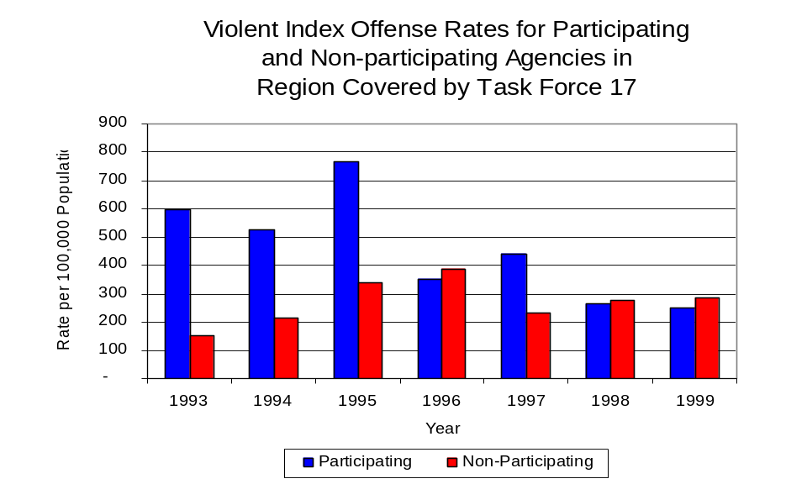
During the period analyzed, the violent Index offense rate for the region covered by Task Force 17 decreased 38 percent, from 427 offenses per 100,000 population in 1993 to 264 offenses per 100,000 population in 1999. Similarly, the violent Index offense rate in the participating agencies decreased 58 percent, from 599 to 249 offenses per 100,000 population, while the rate in the non-participating agencies increased 87 percent, from 153 to 286 offenses per 100,000 population (Figure 1). Thus, while the violent Index offense rate was collectively higher across the jurisdictions that did not participate in Task Force 17 than it was among the combined jurisdictions that did participate in Task Force 17, the violent Index offense rate has decreased during the period analyzed in those agencies that participate in Task Force 17, while increasing in those agencies that do not participate in Task Force 17.
Source: ICJIA calculations using
Illinois State Police and U.S. Census Bureau data
Figure 1

Across the 31 individual local law enforcement agencies covered by Task Force 17’s jurisdiction, three agencies, the Mendota Police Department, the Streator Police Department and the LaSalle County Sheriff’s Office, accounted for one-half of all violent offenses reported to the police (Figure 2). Twenty agencies had fewer than ten violent offenses reported in 1999 and are excluded from Figure 2. When controlling for differences in the populations served by these law enforcement agencies, the violent Index offense rate ranged from zero in eight agencies to 1,324 violent Index offenses per 100,000 population in Mendota.
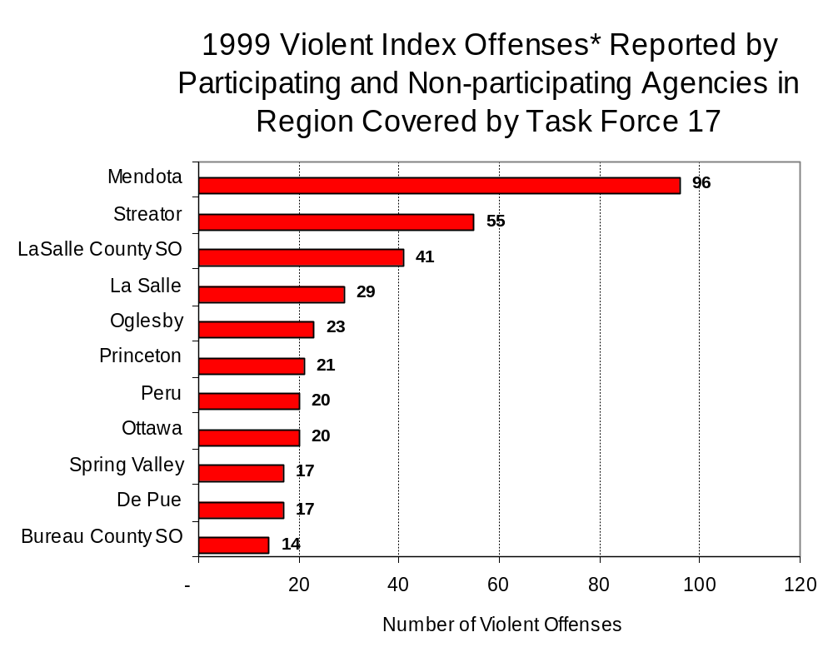
Source: Illinois State Police *Agencies reporting ten or more violent offenses
Figure 2

An indicator of the workload that law enforcement agencies place on other components of the justice system is the number of arrests made by police, including those for violent and property Index offenses and drug offenses. Unlike offenses, which are what police must respond to, arrests represent those offenders who may eventually be processed through other components of the justice system, including the courts, county jails, and state and local correctional programs.

Between 1993 and 1999, the number of arrests for violent Index offenses made by law enforcement agencies in the region covered by Task Force 17 decreased 29 percent, from 311 to 220. As with reported violent Index offenses, the majority (84 percent) of violent Index arrests were for aggravated assaults, followed by criminal sexual assaults (7 percent).

During the period analyzed, the violent Index arrest rate for the region covered by Task Force 17 also decreased 30 percent, from 215 offenses per 100,000 population in 1993 to 151 arrests per 100,000 population in 1999. Similarly, the violent Index arrest rate in the participating agencies decreased 54 percent, from 288 to 134 offenses per 100,000 population, while the rate in the non-participating agencies increased 81 percent, from 99 to 179 offenses per 100,000 population (Figure 3).

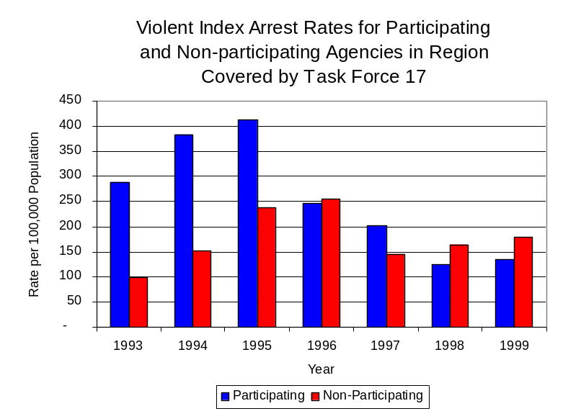
Figure 3
Source: ICJIA calculations using
Illinois State Police and U. S. Census Bureau data

The majority (52 percent) of arrests for violent Index offenses occurring in the two-county region covered by Task Force 17 were made by four agencies. Twenty-two agencies had fewer than ten arrests for violent Index offenses reported in 1999 and are excluded from Figure 4. Of the 163 violent Index arrests made in 1999, the LaSalle County Sheriff’s Office accounted for the majority (16 percent), followed by the LaSalle Police Department (13 percent), the Mendota Police Department (12 percent) and the Streator Police Department (11 percent) (Figure 4).
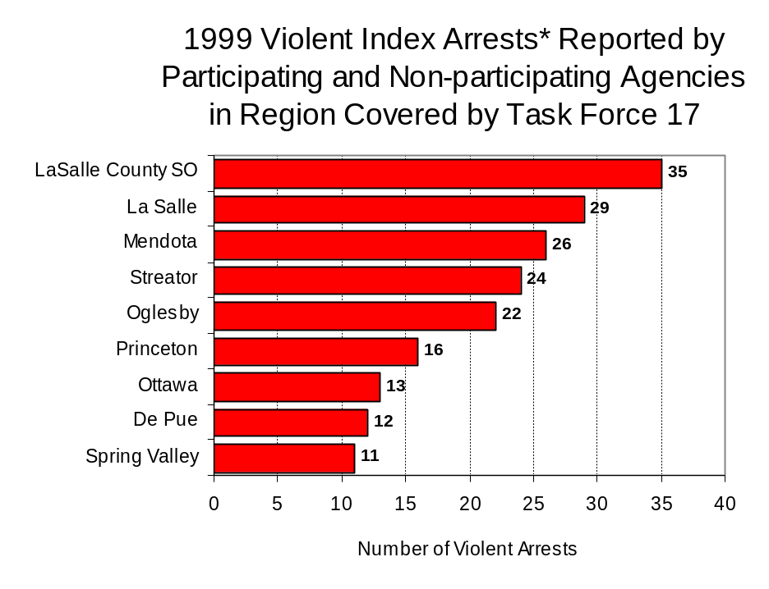
Figure 4
Source: Illinois State Police *Agencies reporting ten or more violent offenses
III. Trends in Drug Arrests

There are two sources of drug arrest data presented in this section. One source is the Illinois Uniform Crime Reporting (I-UCR) program that includes information submitted by local law enforcement agencies on the number of persons arrested for violations of Illinois’ Cannabis Control Act, Controlled Substances Act, Hypodermic Syringes and Needles Act, and Drug Paraphernalia Control Act. In addition, data on drug arrests made by Illinois’ MEGs and task forces are reported to the Illinois Criminal Justice Information Authority. In some jurisdictions, arrests made by the MEG or task force may be reported by both local law enforcement agencies through the I-UCR and to the Authority by the unit. In other jurisdictions, arrests made by the MEG or task force are only reported to the Authority by the unit. Therefore, in some instances drug arrests may be double counted – included in both local agency statistics reported to I-UCR and those of the MEG or task force. Currently there is no mechanism in place to ensure that drug arrest statistics are not being duplicated at both the local agency and MEG/task force level. This should be kept in mind when interpreting the information presented in the following section.

The majority of drug offenses in Illinois are violations of either the Cannabis Control Act – which prohibits the possession, sale and cultivation of marijuana – or the Controlled Substances Act – which prohibits the possession, sale, distribution or manufacture of all other illegal drugs, such as cocaine and opiates. Illinois also has various other laws prohibiting other drug-related activity. These include the Hypodermic Syringes and Needles Act – which prohibits the possession or sale of hypodermic instruments – and the Drug Paraphernalia Control Act – which prohibits the possession, sale or delivery of drug paraphernalia. In general, violations of Illinois Controlled Substances Act are considered to be more serious, since they primarily involve cocaine, heroin, methamphetamine, and hallucinogens, and are almost all classified under Illinois law as felonies. The majority of cannabis and drug paraphernalia offenses encountered by police, on the other hand, tend to be misdemeanor-level offenses.

In 1999, local law enforcement agencies in the counties covered by Task Force 17 reported 897 arrests for drug law violations, dramatically higher than the 165 arrests in 1993. Between 1993 and 1999, arrests for violations of Illinois’ Cannabis Control Act consistently out-numbered arrests for violations of the Controlled Substances Act in Bureau and La Salle counties combined. During the same period, the number of arrests for violations of the Cannabis Control Act in these two counties, combined, more than tripled, from 123 to 405. Arrests for violations of the Controlled Substances Act, in the two-county region combined, also more than tripled, from 35 to 131. In addition, arrests for violations of the Drug Paraphernalia Control Act, enacted in 1993, increased from three in 1993 to 357 in 1999. Much of this increase can be attributed to a 1994 addition to the Drug Paraphernalia Control Act, which included the possession of drug paraphernalia as a violation.

Because arrests for violations of the Drug Paraphernalia Control Act are frequently made in conjunction with other drug offense arrests, these arrests may be double-counted, thus skewing the actual number of drug arrests. Therefore, only arrests for violations of the Cannabis Control Act and Controlled Substances Act will be used for drug arrest comparisons between Task Force 17 and the participating and non-participating agencies.

During the period analyzed, the drug arrest rate for cannabis and controlled substances, combined, in the region covered by Task Force 17 increased more than tripled, from 109 arrests per 100,000 population in 1993 to 369 arrests per 100,000 population in 1999. Similarly, the drug arrest rate in the participating and non-participating agencies also more than tripled, from 123 to 413 and 88 to 301 arrests per 100,000 population, respectively. The drug arrest rate for Task Force 17 increased 36 percent, from 107 to 145 arrests per 100,000 population (Figure 5). Thus, the drug arrest rate tended to be higher collectively in the jurisdictions that participate in Task Force 17 than in those jurisdictions that do not participate in Task Force 17. Although the drug arrest rate achieved by Task Force 17 was significantly lower than the rate experienced by participating agencies, the unit, with just eight officers, made one arrest for a violation of the Cannabis Control or Controlled Substances Acts, for every three arrests made by all of the participating agencies combined.
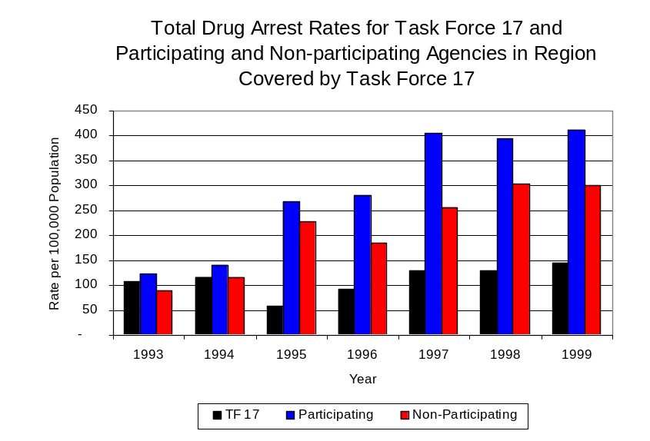
Source: ICJIA calculations using Illinois State Police,
Task Force 17 and U.S. Census Bureau data
Figure 5

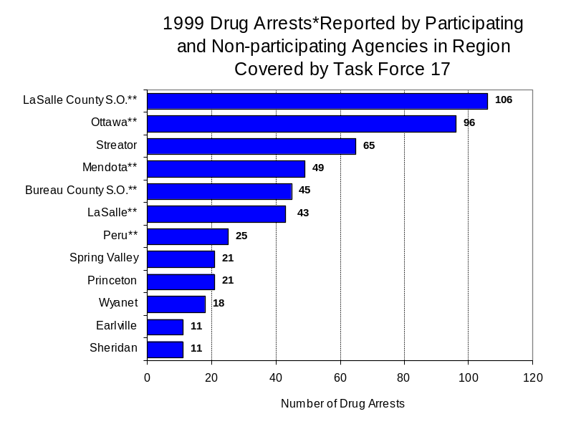
Across the individual local law enforcement agencies in the region covered by Task Force 17, the number of cannabis and controlled substance arrests ranged from zero to 106. Of the 536 drug arrests made during 1999 in the two-county region, six agencies accounted for three-quarters of these drug arrests. Nineteen agencies had fewer than ten drug arrests reported in 1999 and are excluded from Figure 6. The LaSalle County Sheriff’s Office accounted for 20 percent of the cannabis and controlled substance arrests in Bureau and LaSalle counties, followed by Ottawa (18 percent), Streator (13 percent), Mendota (9 percent) and Bureau County Sheriff’s Office and LaSalle (8 percent each) (Figure 6). All six agencies participating in Task Force 17 were among the 12 agencies with the highest number of drug arrests during 1999.
Figure 6
Source: Illinois State Police *Agencies reporting 25 or more drug arrests
**Agencies participating in Task Force 17

In addition to the dramatic difference in the number of drug arrests made, there are also
differences in the types of drug law violation arrests across the agencies in the region. In 1999, violations of the Cannabis Control Act and the Drug Paraphernalia Control Act accounted for the majority of arrests across most individual agencies in the region covered by Task Force 17 (Figure 7).
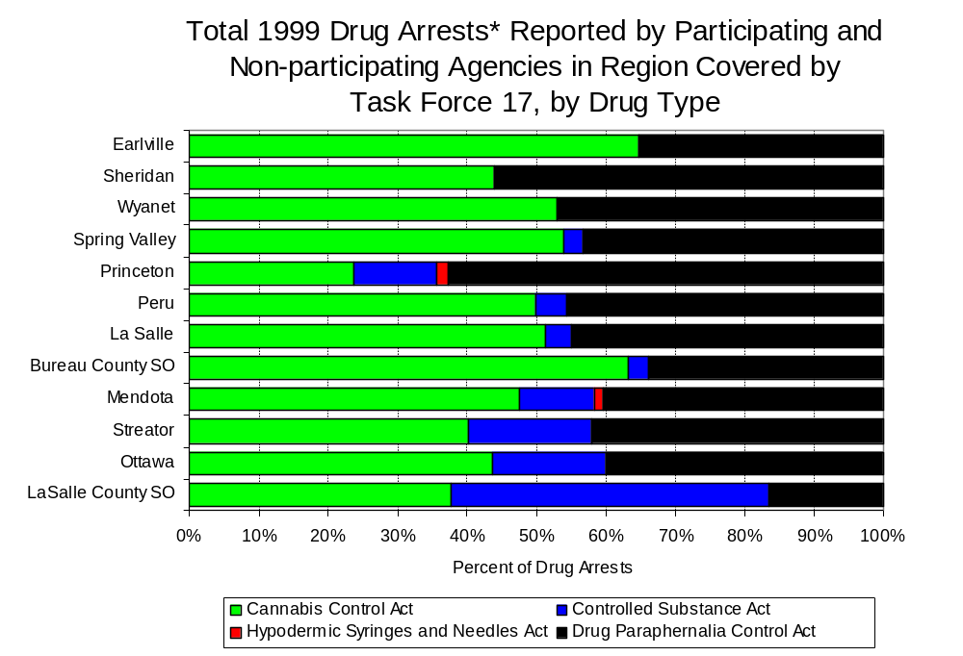
Figure 7
Source: Illinois State Police *Agencies reporting ten or more drug arrests

Between 1993 and 1999, the number of combined cannabis and controlled substances arrests made by Task Force 17 increased 27 percent, from 41 to 52 (Figure 8). Like drug arrests made by most local police departments in the region, violations of the Cannabis Control Act accounted for the majority of drug arrests made by Task Force 17 throughout most of the period analyzed.

During the period analyzed, the number of Task Force 17 arrests for violations of the Cannabis Control Act remained unchanged at 65 in both 1993 and 1999, while arrests for violations of the Controlled Substances Act more than doubled, from 30 to 63 (Figure 8).

Between 1993 and 1999, the proportion of drug arrests accounted for by controlled substance violations increased for participating and non-participating agencies and Task Force 17. In 1999, 49 percent of the drug arrests made by Task Force 17 were for violations of the Controlled Substances Act, compared to 32 percent in 1993; whereas, in 1999, arrests for controlled substances violations accounted for 28 percent of the drug arrests made in the participating agencies and 11 percent for the non-participating agencies, compared to 17 percent and zero percent, respectively, in 1993. Thus, arrests by Task Force 17 were more likely than arrests by either participating or non-participating agencies to involve violations of Illinois’ Controlled Substances Act, as opposed to the Cannabis Control Act. One interpretation of this pattern is that Task Force 17 is more focused in who they are targeting and arresting than local departments, and are also getting a more serious drug law violator, since violations of the Controlled Substances Act are more likely to involve felony-level offenses.

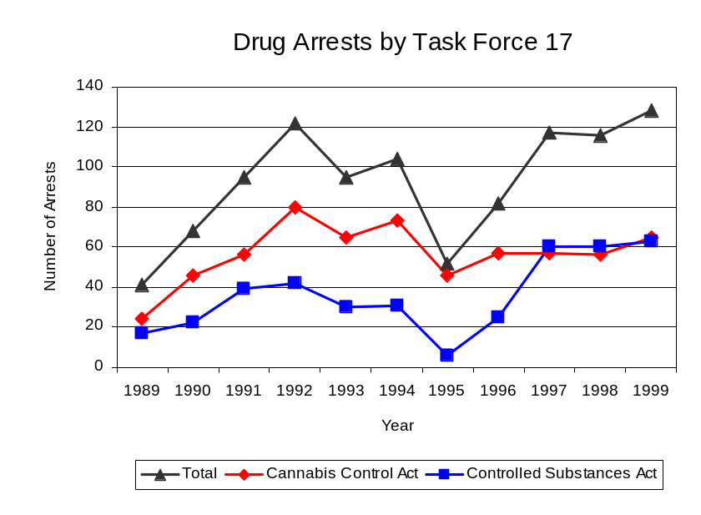
Source: Task Force 17
Figure 8

The data presented below represent the percent of total drug arrests made by participating agencies accounted for by Task Force 17. An upper and lower bound is shown in Figure 9 which accounts for whether or not the units numbers are counted as part of the UCR submissions made by local departments (which is unknown at this point). The upper bound indicates the percentage of arrests if none of the Task Force 17 arrests are included in the local UCR submissions. The lower bound indicates the percentage if all of the Task Force 17 arrests are included in the local UCR submissions. It is estimated that the proportion of all drug arrests across the participating agencies accounted for by Task Force 17 was between 47 to 87 percent in 1993, but decreased to between 14 to 16 percent in 1999. Thus, despite the fact that the officers assigned to Task Force 17 accounted for a small proportion of total officers in the region, they accounted for a relatively large proportion of the drug arrests in the region.
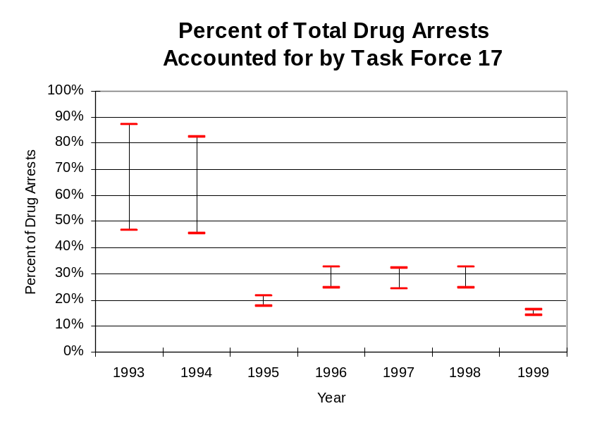
Figure 9
Source: ICJIA calculations using
Illinois State Police and Task Force 17 data

The number of arrests for violations of Illinois’ Cannabis Control Act in Bureau and LaSalle counties increased more than four-fold between 1993 and 1999, from 102 to 534. Between 1993 and 1999, the proportion of all drug arrests accounted for by violations of the Cannabis Control Act in the two-county region decreased from 84 percent to 62 percent. Agencies participating in Task Force 17 accounted for the largest portion (88 percent) of the total number of arrests for cannabis violations. Task Force 17 reported a total of 65 arrests for cannabis violations in 1999, 51 percent of the unit's drug arrests.

During the period analyzed, the cannabis arrest rate increased more than four-fold for the region covered by Task Force 17 and both participating and non-participating agencies. The cannabis arrest rate in the two-county region increased from 71 arrests per 100,000 population in 1993 to 368 arrests per 100,000 population in 1999. Similarly, the cannabis arrest rate in the participating agencies increased from 101 to 534 arrests per 100,000 population, while the arrest rate in the non-participating agencies increased from 22 to 110 arrests per 100,000 population. The cannabis arrest rate for Task Force 17, on the other hand, increased only slightly, from 73 to 74 arrests per 100,000 population (Figure 10). Thus, the arrest rate for violations of the Cannabis Control Act was collectively higher in the area served by participating agencies than in the combined jurisdictions of the non-participating agencies.
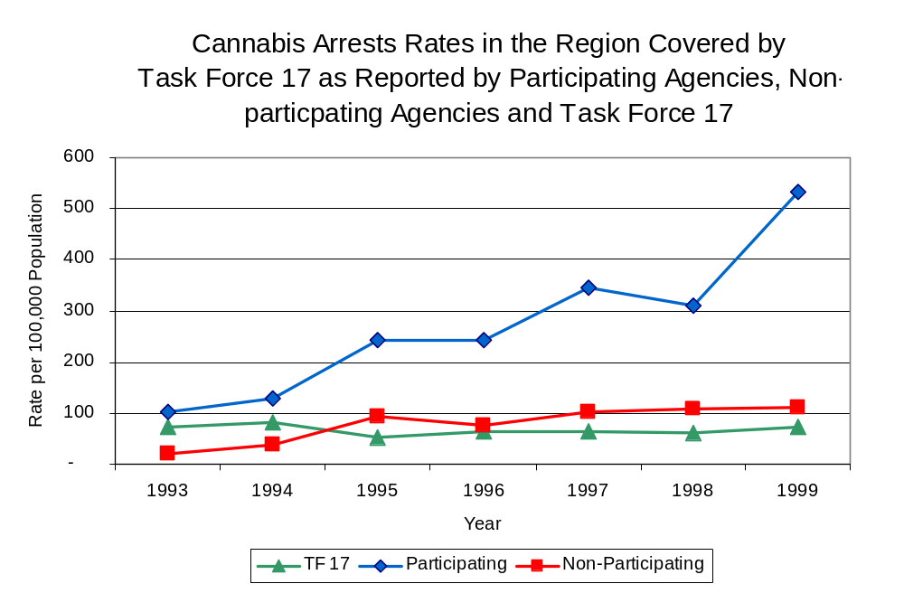
Source: ICJIA calculations using
Illinois State Police and Task Force 17 data
Figure 10

The data presented in Figure 11 represent the percent of cannabis arrests made by participating agencies accounted for by Task Force 17. An upper and lower bound is shown which accounts for whether or not the unit’s numbers are counted as part of the UCR submissions made by local departments (which is unknown at this point). The upper bound indicates the percentage of arrests if none of the Task Force 17 arrests are included in the local UCR submissions. The lower bound indicates the percentage if all of the Task Force 17 arrests are included in the local UCR submissions. It is estimated that the proportion of cannabis arrests across participating agencies accounted for by Task Force 17 was between 19 to 64 percent in 1993, but decreased to between 17 to 20 percent in 1999.

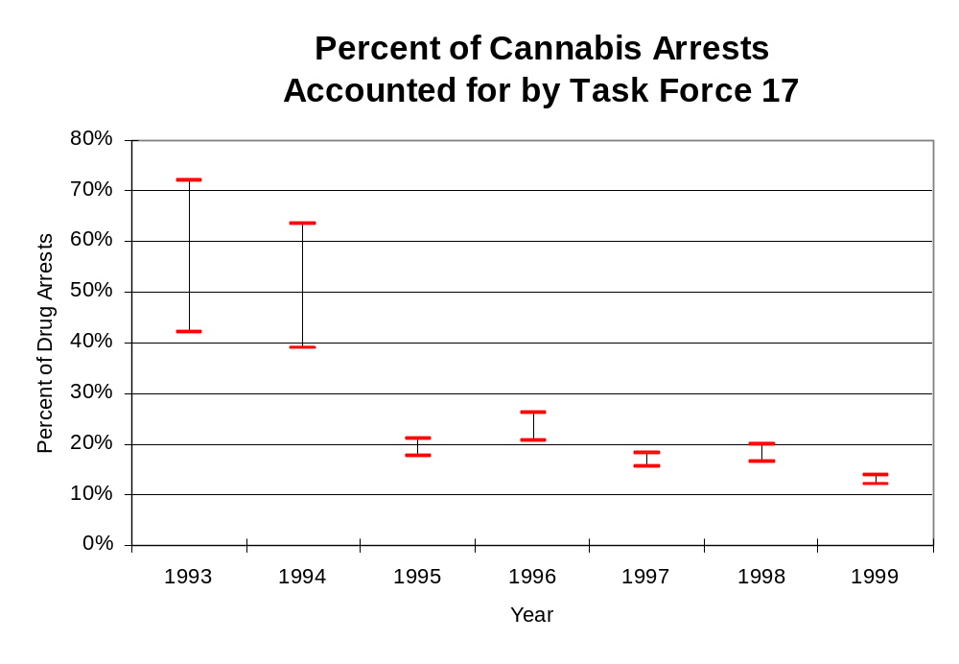
Figure 11
Source: ICJIA calculations using
Illinois State Police and Task Force 17 data

In Bureau and LaSalle counties the number of arrests for violations of Illinois’ Controlled Substances Act increased dramatically between 1993 and 1999, from 19 to 321. Between 1993 and 1999, the proportion of all drug arrests accounted for by violations of the Controlled Substances Act in the two-county region increased from 16 percent to 38 percent. In 1999, Task Force 17 reported 63 arrests for controlled substance violations, 51percent of all drug arrests reported to the Authority by the unit.

Between 1993 and 1998, the arrest rate for controlled substances act violations for the region covered by Task Force 17 remained relatively stable. However, in 1999, the arrest rate for controlled substances act violations jumped to a period high of 226 arrests per 100,000 population, increasing more than 16-fold from the 1993 rate of 13 arrests per 100,000 population (Figure 12). This increase was driven by a dramatic increase in the controlled substances arrest rate in the participating agencies, which increased from 21 to 364 arrests per 100,000 population between 1993 and 1999. The arrest rate in the non-participating agencies also increased during the period analyzed, increasing from zero to 14 arrests per 100,000 population. The controlled substances arrest rate for Task Force 17 more than doubled, from 34 to 71 arrests per 100,000 population (Figure 12). Thus, the Controlled Substances Act arrest rate was significantly higher in the participating agencies than the non-participating agencies.

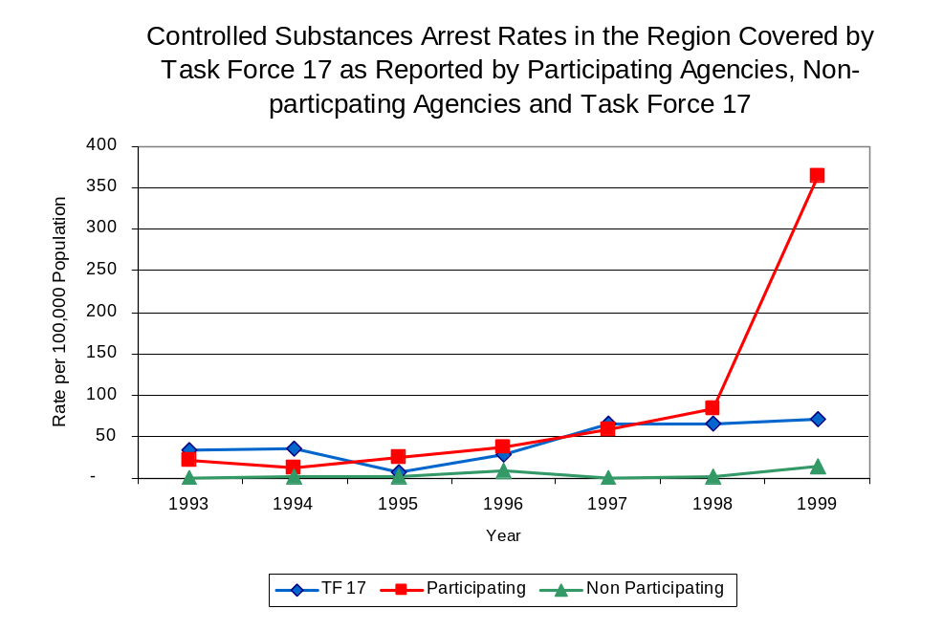
Figure 12
Source: ICJIA calculations using Illinois State Police and Task Force 17 data

The data presented in Figure 13 represent the percent of controlled substances arrests made by participating agencies accounted for by Task Force 17. An upper and lower bound is shown which accounts for whether or not the units numbers are counted as part of the UCR submissions made by local departments (which is unknown at this point). The upper bound indicates the percentage of arrests if none of the Task Force 17 arrests are included in the local UCR submissions. The lower bound indicates the percentage if all of the Task Force 17 arrests are included in the local UCR submissions. It is estimated that the proportion of controlled substances arrests across the participating agencies accounted for by Task Force 17 was between 61 to 100 percent in 1993, but decreased to between 16 to 19 percent in 1999.
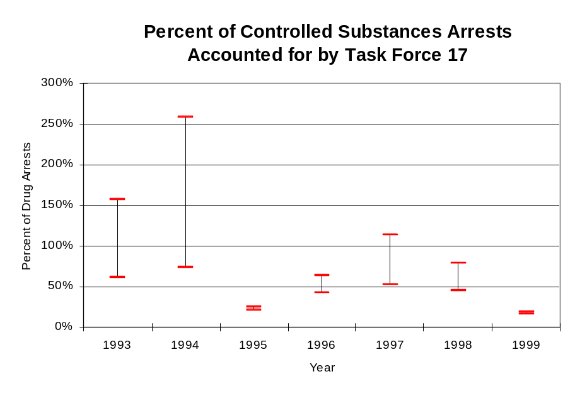
Figure 13
Source: ICJIA calculations using
Illinois State Police and Task Force 17 data

The majority (74 percent) of all drug arrests reported by Task Force 17 are for delivery. Between 1993 and 1999, the number of drug delivery arrests made by Task Force 17 increased, from 80 to 86. When cannabis and controlled substance arrests were examined separately, during the period analyzed, the proportion of arrests accounted for by delivery offenses varied. Similar to arrests for cannabis violations, the proportion of cannabis delivery offenses remained relatively stable between 1993 and 1999, decreasing slightly from 85 percent to 80 percent, while accounting for 64 percent of the total number of cannabis arrests made during the entire period analyzed. Conversely, while the number of arrests for violations of the Controlled Substances Act more than doubled, the proportion of arrests for the delivery of controlled substances decreased significantly, from 83 percent in 1993 to 51 percent in 1999, while accounting for 79 percent of all arrests for violations of the Controlled Substances Act during the period analyzed.

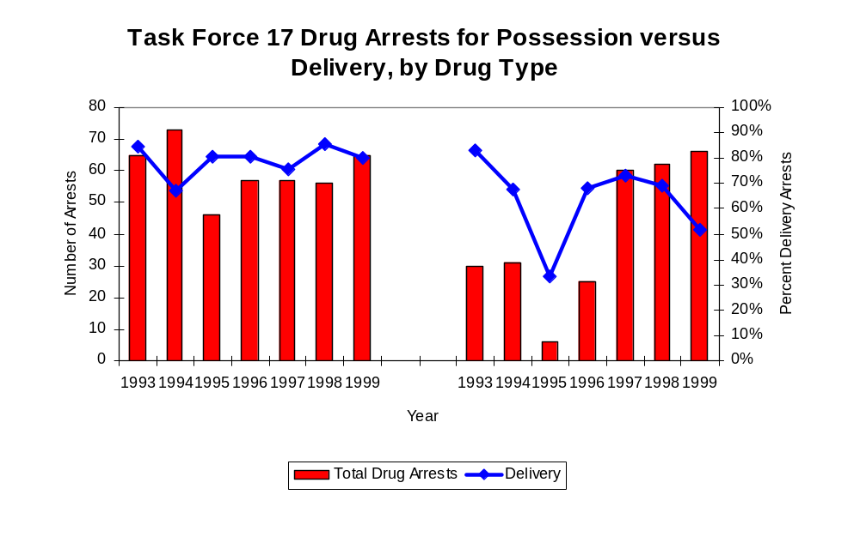
Figure 14
Source: ICJIA calculations using Task Force 17 data
Cannabis Control Act

Controlled Substances Act

IV. Trends in Drug Seizures

Drugs seized by law enforcement agencies are another indicator of the extent and nature of illegal drug trade in a jurisdiction. When illegal drugs are seized by law enforcement agencies, all or a portion of the total amount seized is submitted to a crime lab for analysis. Most agencies submit drugs to one of the Illinois State Police crime labs. These labs record the quantity of drugs submitted from each county. This section discusses trends in the quantities of illegal drugs seized and submitted to the Illinois State Police from local law enforcement agencies in Bureau and LaSalle counties as well as the quantities of drugs seized by Task Force 17. It is important to note, however, that while Task Force 17 data report the total quantities of drugs actually seized, local agency data only represent the quantities of seized drugs that are submitted to the Illinois State Police for analysis. County-level cannabis, cocaine and methamphetamine seizure rates for Illinois' 102 counties are provided in maps located in the Appendix of this report.

As in most Illinois jurisdictions, cannabis accounts for the majority of illegal drugs seized in the two-county region covered by Task Force 17. The quantity of cannabis seized and submitted by law enforcement agencies in Bureau and LaSalle counties decreased 33 percent, from 420,192 grams in 1993 to 279,464 grams in 1999. The quantity of cannabis seized by Task Force 17 decreased dramatically between 1993 and 1999, from 3,684,573 grams to 2,947 grams (Figure 15). In 1999, Task Force 17's cannabis seizure rate of 3,340 grams per 100,000 population was much lower than the statewide cannabis seizure rate of 31,533 grams per 100,000 population, and also lower than the seizure rate of 192,386 grams per 100,000 population in the two-county region covered by Task Force 17 (Map 2).

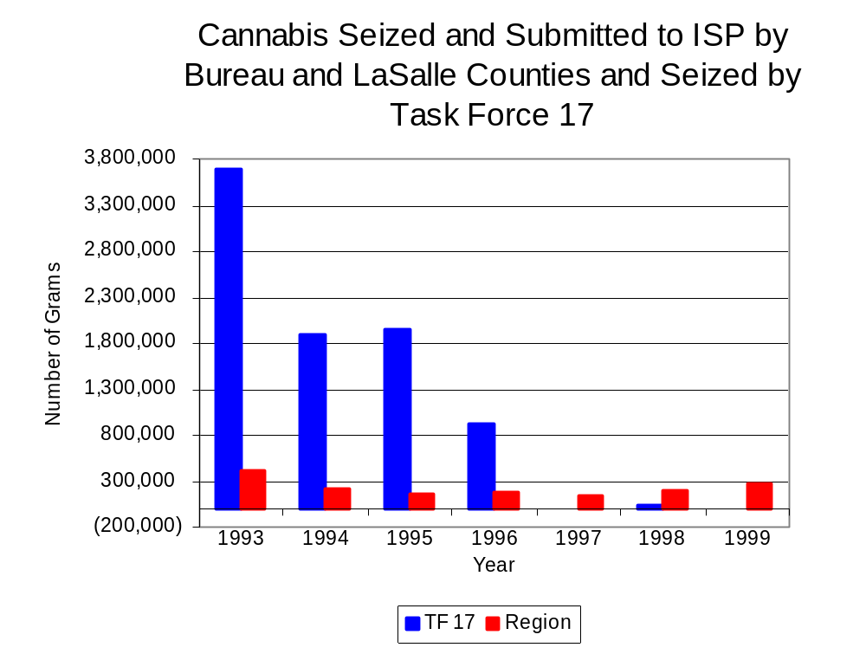
Figure 15
Source: Illinois State Police and Task Force 17

Between 1993 and 1999, a combination of crack and powder cocaine has accounted for a small proportion of drugs seized in the two-county region covered by Task Force 17. However, the quantity of cocaine seized and submitted by law enforcement agencies in Bureau and LaSalle counties decreased 83 percent, from 59,047 grams in 1993 to 10,210 grams in 1999. Between 1993 and 1999, the quantity of cocaine seized by Task Force 17 decreased dramatically, from 456,933 grams to just 237 grams.

The proportion of all cocaine seized accounted for by powder cocaine remained relatively stable between 1993 and 1999, although in 1998, the proportion of all cocaine seized accounted for by powder cocaine dropped to 50 percent of the cocaine seized in the two-county region covered by Task Force 17. For Task Force 17, powder cocaine accounted for nearly all of the total cocaine seized throughout the period analyzed, decreasing only slightly from 100 percent in 1993 to 98 percent in 1999 (Figure 16). In 1999, Task Force 17's cocaine seizure rate of 268 grams per 100,000 population was less than the cocaine seizure rate of 7,029 grams per 100,000 population in the two-county region covered by Task Force 17, and less than the statewide cocaine seizure rate of 15,735 grams per 100,000 population (Map 3).
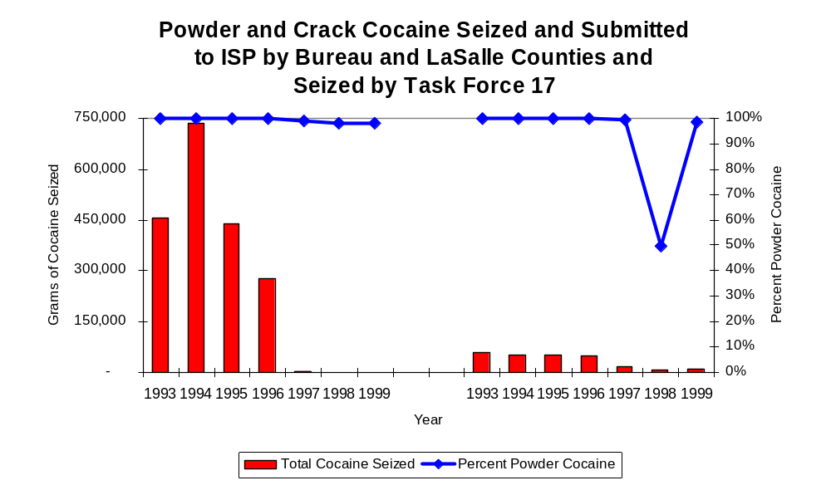
Figure 16
Source: Illinois State Police and Task Force 17
Task Force 17
Region

The total quantity of illegal drugs seized and submitted by law enforcement agencies in Bureau and LaSalle counties decreased between 1993 and 1999, from 480,517 grams to 289,831 grams. The total quantity of illegal drugs seized by Task Force 17 has decreased from 4,144,316 grams in 1993 to 31,608 grams in 1999.

Methamphetamine seizures accounted for a small portion of illegal drugs seized in the two-county region where Task Force 17 operates. Between 1993 and 1999, only 98 grams of methamphetamine were seized. During this period, Task Force 17 reported no methamphetamine seizures. The largest amount seized (84 grams) was in 1999, resulting in a seizure rate of 58 grams per 100,000 population, 67 percent lower than the state’s seizure rate of 97 grams per 100,000 population (Map 4).

Trends in Prosecutions for Drug Offenses and All Felonies

Although Illinois has one of the best court reporting systems in the country, the Administrative Office of the Illinois Court only collects information regarding the aggregate number of court filings. Currently, there are no statewide data available on court filings by offense type. The Administrative Office of the Illinois Courts reports data on felony criminal court cases. After screening a case and deciding it warrants further action, the state’s attorney must file formal charges in court. Felony cases can be punished by a probation term up to four years and incarceration for more than one year.

Between 1989 and 1999, the number of felony filings in the two-county region covered by Task Force 17 increased 66 percent, from 384 to 602 (Figure 17).

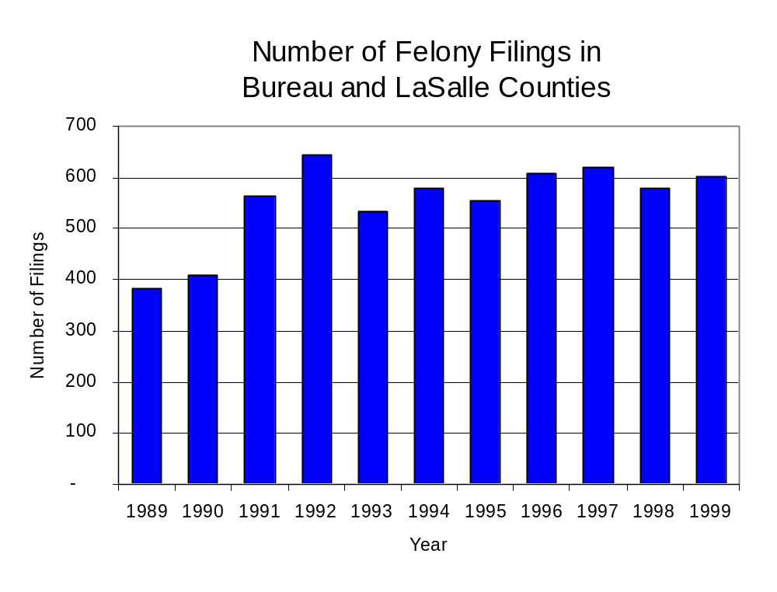
Figure 17
Source: Administrative Office of the Illinois Courts

Between 1989 and 1999, there were a total of 991 drug prosecutions initiated as a result of Task Force 17 arrests in Bureau and LaSalle counties. During this time, the number of Task Force 17 drug arrests more than tripled, from 41 arrests in 1989 to 128 arrests in 1999 (Figure 18). Between 1989 and 1999 (with the exception of 1990), the proportion of Task Force 17 drug arrests resulting in prosecution remained relatively stable, resulting in 97 percent of drug arrests by Task Force 17 being prosecuted. In some years, the proportion of arrests resulting in a prosecution exceeded 100 percent. This is due to some slight differences in the timing of an arrest and the filings of charges, or could be due to charges, rather than defendants, being reported by the unit. In addition, some offenders have charges filed, and a subsequent warrant issued, without an arrest taking place.

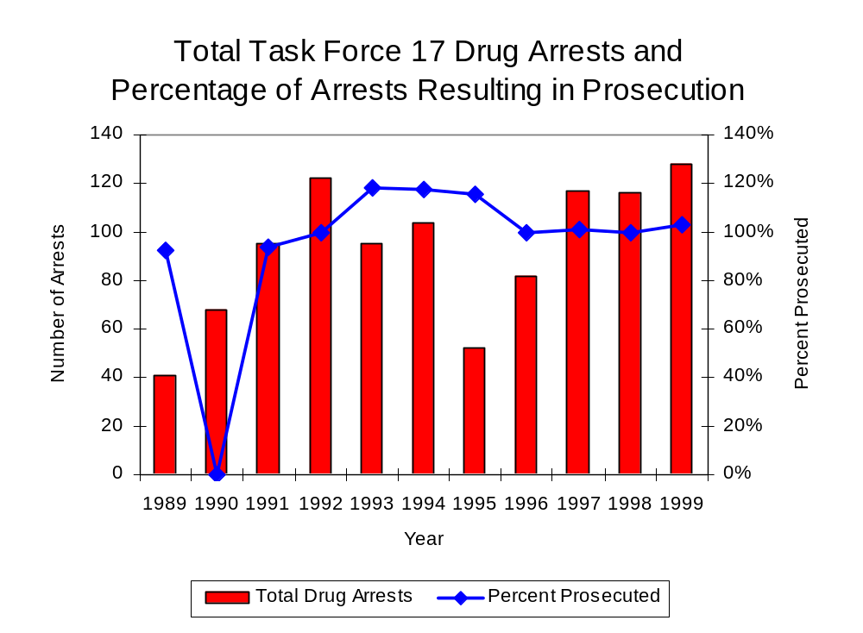
Figure 18
Source: Task Force 17

Between 1989 and 1999, the majority (715) of the 991 drug offenders who were prosecuted as a result of Task Force 17 activity were convicted. Convictions for controlled substances accounted for 43 percent of all Task Force 17 initiated convictions during the period analyzed.

VI. Trends in Percent of Convicted Drug Offenders Sentenced to Prison

Anyone convicted of a felony in Illinois can be sentenced either to prison or probation, or receive conditional discharge. A number of factors influence the type and length of sentence imposed on convicted felons, including the severity of the crime, the offender’s criminal and social history, safety of the community and legislation affecting certain types of offenses. For some types of convictions, a sentence to prison is required by state statute.

Between 1989 and 1999, the number of offenders convicted of a felony and sentenced in the two-county region covered by Task Force 17 increased 50 percent, from 343 to 516. While the number of convicted felons sentenced to the Illinois Department of Corrections (IDOC) increased 56 percent between 1989 and 1999, from 139 to 217, the proportion of felons sentenced to IDOC increased slightly during the same period, from 41 percent to 42 percent of total felony sentences. In 1999, 277 probation sentences were imposed on convicted felons, 36 percent more than the 204 probation sentences in 1989 (Figure 19). As a result, the proportion of felons sentenced to probation decreased from 59 percent in 1989 to 54 percent in 1999. Sentences other than prison or probation account for the remaining 4 percent of felony sentences imposed in 1999.

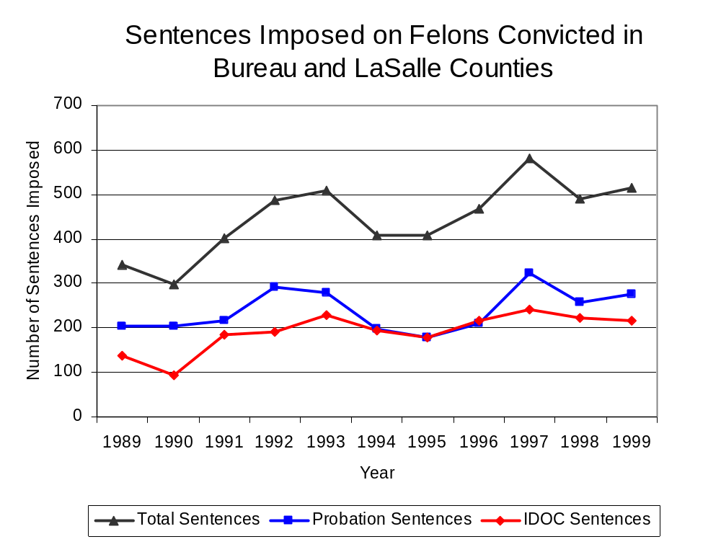
Figure 19
Source: Administrative Office of the Illinois Courts

Between 1989 and 1999, the number of Task Force 17 drug offenders convicted and sentenced increased from zero to 104. During the period analyzed, the number of convicted Task Force 17 drug offenders sentenced to probation increased from zero in 1989 to 15 in 1999, although in 1994, the number of convicted Task Force 17 drug offenders sentenced to probation reached an all time high of 49. Similarly, the number of convicted Task Force 17 drug offenders sentenced to jail increased from zero to 36 and the number of drug offenders sentenced to prison increased from zero to 53 (Figure 20). In 1999, among those Task Force 17 drug offenders convicted and sentenced, prison sentences accounted for the largest proportion (51 percent), followed by jail sentences (35 percent) and probation sentences (14 percent).

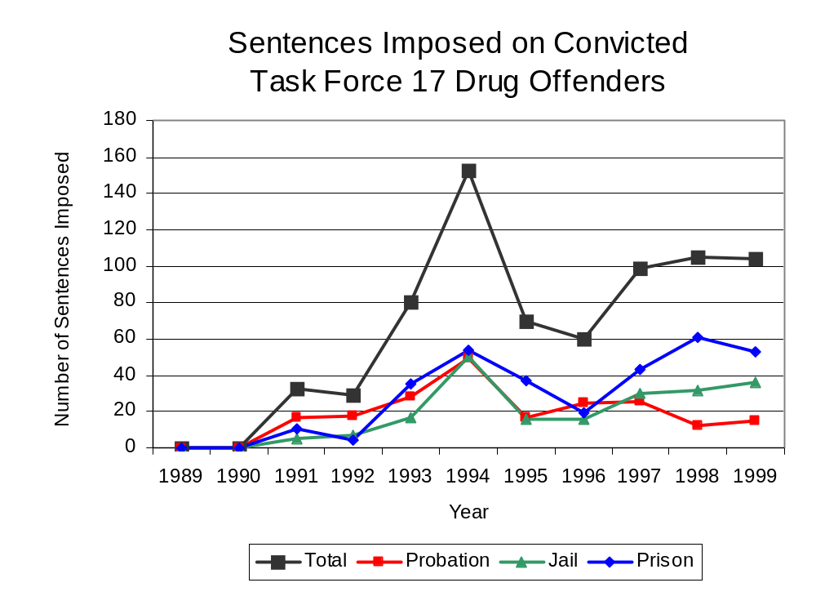
Figure 20
Source: Task Force 17

Between state fiscal years 1989 and 1999, the number of new court commitments to IDOC’s Adult Division for drug offenses from the two-county region covered by Task Force 17 more than doubled, from 30 to 72. The number of drug offender admissions by Task Force 17 also increased from zero to 54 between 1989 and 1999 (Figure 21). Thus, during the period analyzed, prison sentences resulting from Task Force 17 cases accounted for one-half of all drug-law violators sentenced to prison from the two-county region where Task Force 17 operates.

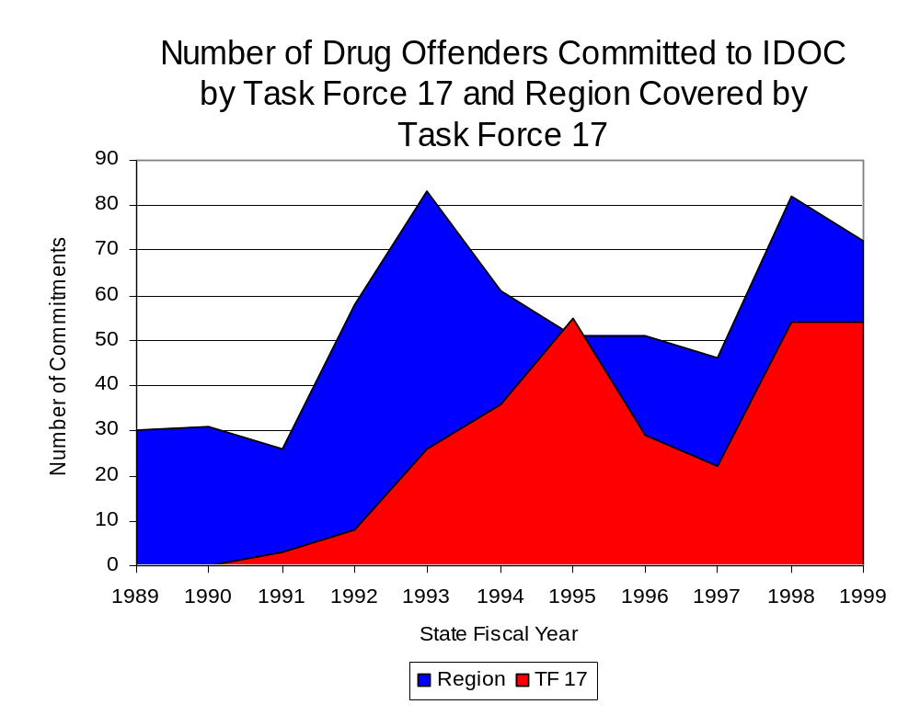
Figure 21
Source: Illinois Department of Corrections and Task Force 17

During the period analyzed, drug offenders accounted for an increasing proportion of adults convicted and sentenced to prison from Bureau and LaSalle counties. In 1989, drug offenses accounted for 26 percent of all commitments to IDOC, compared to 42 percent in 1999 (Figure 22).

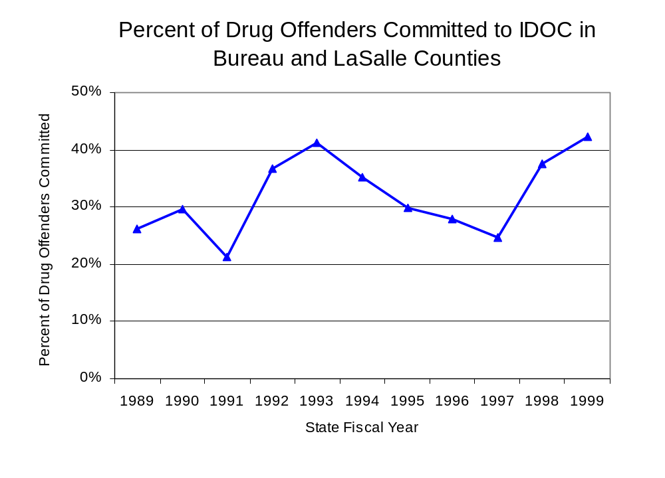
Figure 22
Source: Illinois Department of Corrections

Penalties for drug offenses were also examined between 1993 and 1999. Class X and Class 2 felonies accounted for the largest proportion (24 percent each) of sentences to IDOC for drug offenses, followed by Class 4 felonies (22 percent), Class 1 felonies (18 percent) and Class 3 felonies (13 percent). Between 1993 and 1999, the number of Class 1 felonies more than doubled, from seven to 17, while Class 4 felony sentences also more than doubled, from ten to 21. Class 2 felony sentences decreased 56 percent, from 16 to seven, while Class 3 felonies decreased 20 percent, from ten to eight and Class X felonies decreased 24 percent, from 25 to 19 (Figure 23).

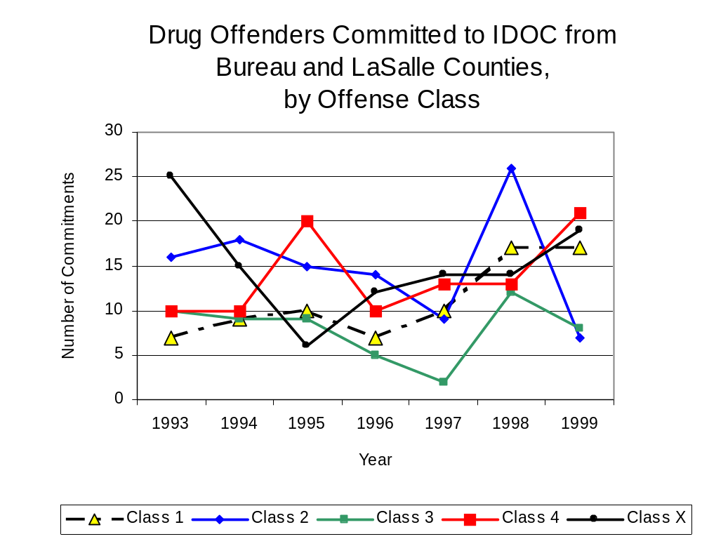
Figure 23
Source: Illinois Department of Corrections

Along with the dramatic increase in Class 4 felony sentences to IDOC between 1993 and 1999, the mean sentence length for Class 4 felonies increased 31 percent from 1.9 to 2.5 years, during the period, while the mean sentence for a Class 1 felonies increased 20 percent, from 5.3 to 6.4 years, and Class 3 sentence lengths increased 30 percent, from 2.3 to 2.9 years. However, the mean sentence length for Class X felonies decreased 55 percent, from 21.5 to 9.8 years, and the mean sentence length for Class 2 felonies decreased 18 percent, from four to 3.3 years.

VII. Trends in Drug Treatment Admissions in Task Force 17 Region by Drug Type

In addition to considering indicators of the extent and nature of drug abuse as reported through the criminal justice system (for example, arrests and prison sentences), there are indicators of substance abuse available from other Illinois social service agencies. Overseeing and supporting treatment for substance users, whether they are referred from the criminal justice system or elsewhere, is the responsibility of the Illinois Department of Human Services’ Office of Alcoholism and Substance Abuse (OASA). It is important to note, however, that while OASA data represent the majority of the overall demand for substance abuse treatment in the state, some private programs provide treatment services to a smaller but significant number of clients who may not be included in the state’s reporting system.

In state fiscal year 1999, OASA reported 1,110 admissions for alcohol or drug abuse treatment from Bureau and LaSalle counties, 27 percent more than the 874 admissions in 1989 (Figure 24). Among the 1,110 admissions to substance abuse treatment in state fiscal year 1999, 58 percent (647) reported alcohol as their primary substance of abuse, while abuse of illicit substances accounted for 38 percent and 4 percent reported no primary substance of abuse.

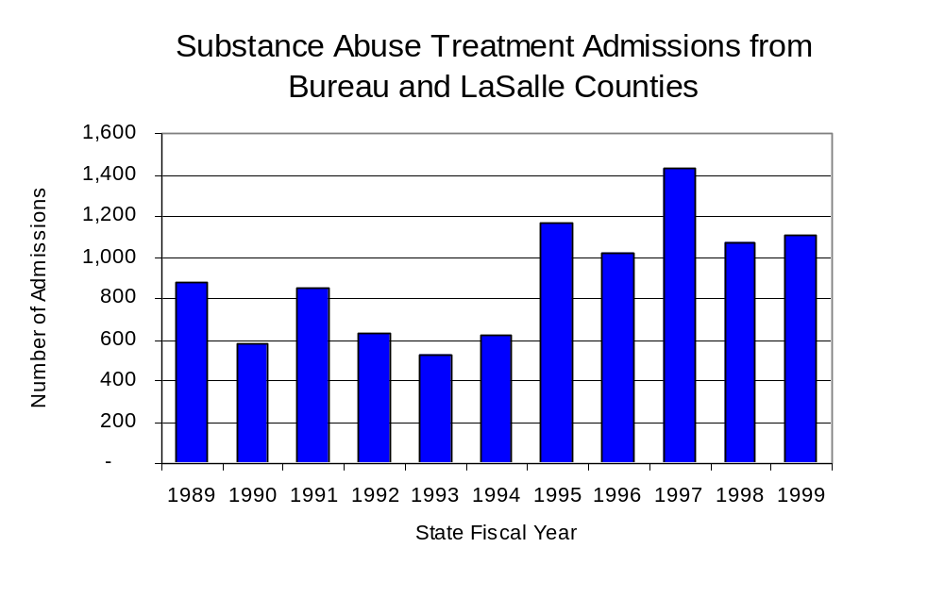
Figure 24
Source: Illinois Department of Human Services’
Office of Alcoholism and Substance Abuse
While drug treatment admissions can be considered a measure of the demand placed on a specific component of the human services system within Illinois, the extent and nature of drug treatment admissions could also be indicative of the substance abuse problem within a particular region. In some respects, the characteristics of those admitted to drug treatment can be considered a profile of the most serious drug abusers in the community, since admission to treatment requires a documented, formal assessment of a drug problem and a level of substance abuse warranting treatment. By comparing the types of drugs of abuse reported by those admitted to substance abuse treatment with the types of drugs involved in law enforcement agency arrests, one can get a sense of the degree to which arrests reflect the drugs which are most problematic within a community.

In the following analyses, the percent of arrests accounted for by drugs classified under Illinois’ Controlled Substances Act (primarily cocaine, heroin, and methamphetamine) versus the Cannabis Control Act (marijuana) across the participating agencies combined, non-participating agencies combined and Task Force 17 are compared to the proportion of drug treatment admissions accounted for by these groups of substances. From these comparisons, a number of general conclusions can be made. First, the proportion of arrests made by Task Force 17 and those participating in Task Force 17 and non-participating agencies accounted for by drugs other than marijuana (Controlled Substances Act offenses) were not very close to the proportion of drug treatment admissions from the covered region accounted for by these substances. Thus, there is considerable lack of convergence between the drugs involved in drug arrests and treatment admissions. The majority of arrests by Task Force 17 and local police departments (those agencies participating in Task Force 17 and non-participating agencies) were for cannabis offenses. Thus, while local arrests may reflect the most widely available and used drug in the region, they tend not to involve the substances considered to be most serious (i.e., felony versus misdemeanor) nor the substances individuals are seeking and receiving treatment for (Figure 25).

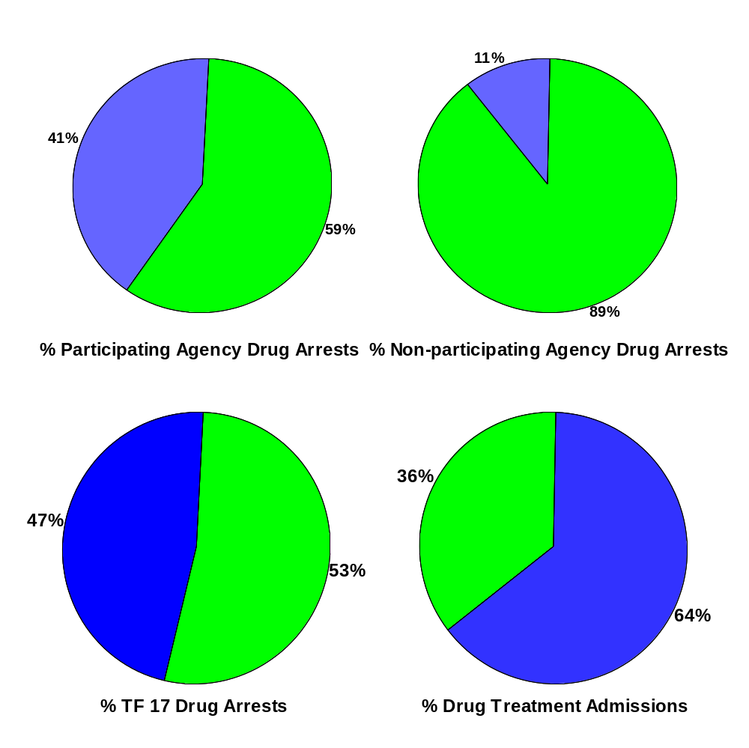
CannabisControlled Substances
Comparison of Drug Arrests by Task Force 17 and Participating and Non-participating Agencies vs. Drug Abuse Treatment Admissions in Bureau and LaSalle Counties, 1999
Source: Illinois Department of Human Service's
Office of Alcoholism and Substance Abuse and
Task Force 17
Figure 25
VIII. Trends in Drug Exposed Births

Illinois continues to experience the effects of prenatal substance abuse. In Illinois, if a baby is born and thought to have been exposed to illegal substances or alcohol, either through observation by physicians or toxicology tests, the case is reported to the Illinois Department of Children and Family Services. These cases are then investigated by DCFS to verify the child’s prenatal exposure to either alcohol or illegal substances. Between state fiscal years 1989 and 1999, nearly one-half (50) of Illinois’ 102 counties reported at least one case of a substance-affected infant.

Between state fiscal years 1989 and 1999, the number of drug-exposed infant cases reported in the two-county region covered by Task Force 17 tripled, from one to three reported cases; however, in 1996, the number of cases reported reached a high of 11. Between state fiscal years 1989 and 1999, 26 cases, or two-thirds of all cases reported, were verified as involving prenatal drug use by a DCFS investigation. Mirroring the trend of reported cases, verified cases of drug-exposed infants in the Task Force 17 region also increased between 1989 and 1999, from zero to three, while increasing to a period high of nine verified cases in 1996 (Figure 26).

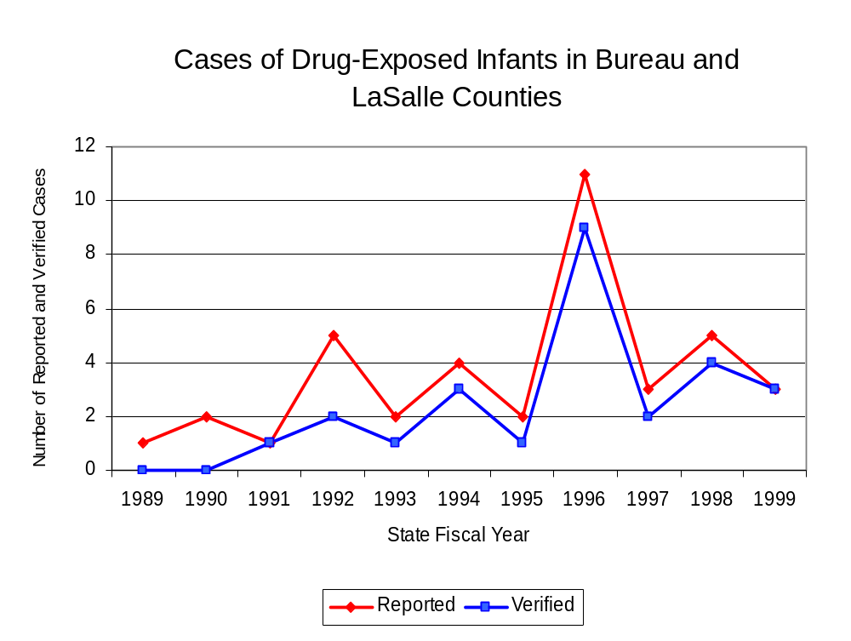
Source: Department of Children and Family Services
Figure 26

IX. Summary of Drug Situation

Although the distribution of illegal drugs is difficult to measure precisely, data obtained from criminal justice sources can be helpful in estimating drug availability. Information from a recent survey of Illinois drug enforcement units, as well as the most up-to-date data available on drug price, are presented as indicators of the drug supply in Illinois.

In 1995, 1996 and 1998, the Authority conducted a survey of each MEG and task force in Illinois to gauge the perceived availability of drugs in the areas they cover. Questions were asked concerning the availability of specific drugs, and results were analyzed by region of the state. MEGs and task forces are classified as being either urban, rural or mixed urban/rural based upon the classification of the county(s) that each unit covers, and, for purposes of this report, are compared to the average of similar units.

According to Task Force 17 survey responses, cannabis, cocaine, crack and methamphetamine continued to be the most visible drugs on the street and were all reported to be “readily available” across all regions analyzed. The perceived availability of cannabis remained relatively unchanged, while methamphetamine increased, across all regions examined, between 1996 and 1998. In addition, the perceived availability of all drug types, except LSD, increased in the region covered by Task Force 17 since the 1996 survey, especially heroin and methamphetamine. Methamphetamine was reported as moderately available across Illinois but available to a higher degree in the region covered by Task Force 17 and by all MEGs and task forces in mostly rural regions. The perceived availability of all drugs, excluding cannabis and crack, tended to be greater in the region covered by Task Force 17 than across Illinois and in other mostly rural regions (Figure 27).
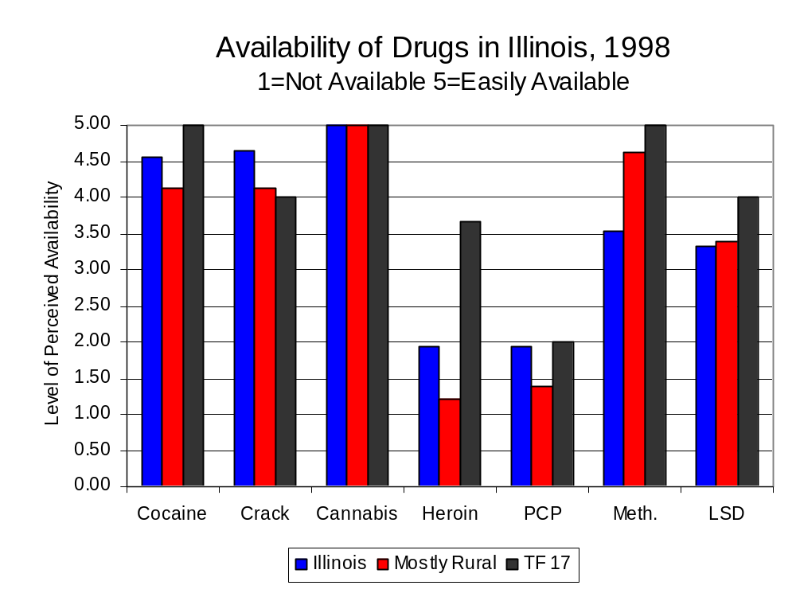
Figure 27
Source: Authority Survey of Illinois MEGs and task forces
Another market indicator that can be used to assess availability is drug price. Lower prices tend to suggest a sufficient supply to meet demand, while increasing prices indicate decreased availability.

Based on a statewide survey of MEG and task force units, the average price of cocaine and cannabis appear to be relatively stable across all regions surveyed in 1998, while prices for all other drug types appear to vary somewhat across Illinois. The average price of cannabis, cannabis, methamphetamine and heroin in the region covered by Task Force 17 decreased between 1996 and 1998, while increasing across Illinois. The 1998 average price of cocaine reported by Task Force 17 was $81 per gram, compared to $98 per gram across Illinois and $98 per gram reported by all MEGs and task forces in other mostly rural regions (Figure 28). The average price of heroin in the region covered by Task Force 17 was reported as $64 per gram, lower than the price of $165 per gram across Illinois and the price of $88 per gram reported by all other MEGs and task forces in mostly rural regions. In 1998, the average price of cannabis was reported as approximately $5 per gram in the Task Force 17 region, $8 per gram in mostly rural regions and $8 per gram across Illinois. The average price of methamphetamine in the region covered by Task Force 17 was reported as $40 per gram, significantly lower than the price of $96 per gram across Illinois and the price of $94 per gram reported by all other MEGs and task forces in mostly rural regions.

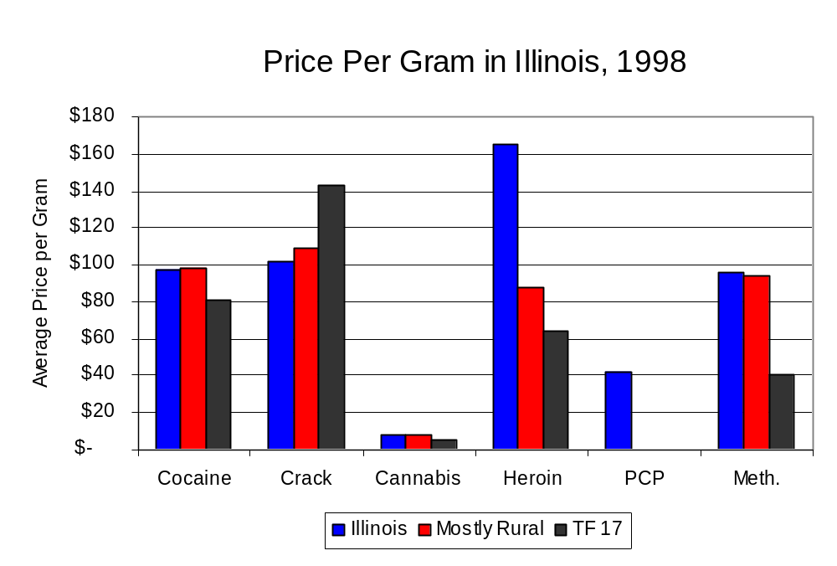
Figure 28
Source: Authority Survey of Illinois MEGs and task forces

X. Appendices
1999 Percent of Illinois'
County-level Population Covered by an Authority-funded Multi-jurisdictional Enforcement Group or Task Force
Map 1
* Shaded counties indicate that at least one law enforcement agency within the county participates in a MEG or task force
Percent of County Population Covered by MEG or Task Force

1999 Illinois
Cannabis
Seizure Rates, by County
Map 2
Cannabis Seizure Rate
(rate per 100,000 population)
1999 Illinois
Cocaine
Seizure Rates, by County
Map 3
Cocaine Seizure Rate
(rate per 100,000 population)
1999 Illinois Methamphetamine
Seizure Rates, by County
Map 4
Methamphetamine Seizure Rate
(rate per 100,000 population)

Bibliography

Administrative Office of the Illinois Courts, Annual Report to the Supreme Court of Illinois.
1989 through 1999 reports, Springfield, Illinois.

Administrative Office of the Illinois Courts’ Probation Division, Statewide Probation Data
Report. 1989 through 1999 reports, Springfield, Illinois.

Illinois Department of Human Services’ Office of Alcoholism and Substance Abuse. Data
provided for state fiscal years 1989 through 1999, Springfield, Illinois.

Illinois Department of Children and Family Services, Child Abuse/Neglect Statistics Report,
1989 through 1999 reports, Springfield, Illinois.

Illinois Department of Corrections. Data provided for fiscal years 1989 through 1999,
Springfield, Illinois.

Illinois State Police, Crime in Illinois. 1993 through 1999 reports, Springfield, Illinois.

Illinois State Police, Drug Statistics Report. Monthly reports, January 1989 through
December 1999, Springfield, Illinois.

Task Force 17. Monthly reports, January 1989 through December 1999, LaSalle, Illinois.

U.S. Bureau of the Census.


George H. Ryan, Governor
Peter B. Bensinger, Chairman
Candice M. Kane, Executive Director

